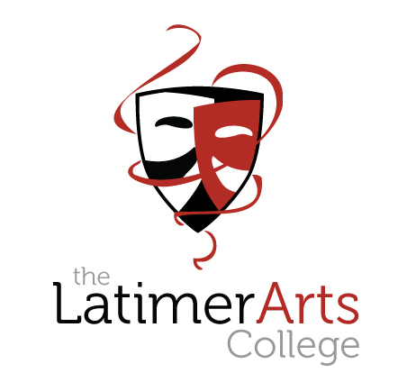

ARTS APTITUDE

APPLICATION PACK 2023

Please return to The Latimer Arts College
no later than 9.00 am on Monday 10th October 2022

Applications received after this date cannot be accepted

Welcome to our Arts Curriculum

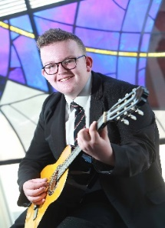
Students enjoy an outstanding arts curriculum at The Latimer Arts College delivered by specialist staff who are passionate about the value that the arts add to a child’s personal development. Through the arts, our students grow into confident and creative young adults, with strong and effective communication and collaborative skills.

In Key Stage 3, all students have weekly lessons in Art, Dance, Drama and Music where an exciting range of themes, genres and techniques are explored. This is enhanced by vibrant extra-curricular opportunities offered through weekly clubs to performances and shows, both at the College and in the local community.
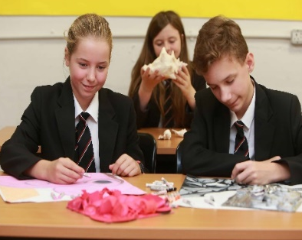
At Key Stages 4 and 5, students can choose to specialise in one discipline or study for qualifications in a range of arts subjects.

Our students have the advantage of being able to study and perform in our Masque Theatre, where they also learn about the technical aspects of delivering a performance in our Dance and Drama studios and they are able to access purpose built, specialist art and design classrooms.

We are proud of our arts curriculum and the outstanding reputation that we have.

If your child shares our passion and commitment, we would love to consider them for one of our arts places.

Applications for September 2023

Guidance notes

This application form is linked to the Local Authority admissions criteria that have been agreed with the Governing Body of The Latimer Arts College, for intake at Year 7 for September 2023.

It will be used as the basis for decision making by The Latimer Arts College which then informs the Local Authority.

Contact may be made by the College with the primary school and other external organisations solely for the purposes of verifying information provided by parent(s)/carer(s).

The procedure is as follows.

- Parent(s)/carer(s) download an Arts Aptitude Application Pack from the College.

- Parent(s)/carer(s) complete the Arts Aptitude application form by 9.00 am on Monday 10th October and submit it to the College.

- Successful applicants will then be invited to attend workshops during the week commencing Monday 17th October.

- Parent(s)/carer(s) will be notified by the College if their child has shown an aptitude for the Arts in a letter that will be sent on Friday 21st October. This will not be an offer of a place, but an indication as to whether an applicant has an aptitude.

The Latimer Arts College operation of the admission criteria for Arts Places – September 2023 entry

Following the allocation of places to students who have an Education, Health and Care (EHC) Plan, which names the school as appropriate provision, when there are more applications for places than there are places available, priority will be given in the following order:

1. Children in public care (looked after children) or previously looked after.

2. Students who will have an older brother or sister continuing at The Latimer Arts College at the time of admission of the younger child.

3. Children of staff where that member of staff has been employed at the College for two or more years at the time at which the application for admission to the College is made, and/or the member of staff is recruited to fill a vacant post for which there is a demonstrable skill shortage in the area.

4. 20 students will be selected for their aptitude in art, dance, drama or music. To be selected through workshops.

5. Those students who live with their parents or carers at an address in Barton Seagrave or the linked town/villages of Burton Latimer, Cranford and Isham (using wards as according to Kettering Borough Council).

6. Other students.

Operation of the Arts Places Criteria

Parent(s)/carer(s) complete both the Local Authority application form and the Arts Aptitude application form if applying for an ‘Arts Aptitude' place (20 places).

During October contact will be made with parent(s)/carer(s) of Arts Aptitude applicants selected on the basis of their application form. Workshops with these students will then be held during the week commencing Monday 17th October 2022.

If selected, your son/daughter will be required to take part in up to two workshops in their preferred art forms, as selected on the application form. Final selection will occur after these workshops.

The Drama Workshop
The workshop is designed to examine the students’ ability to use Drama techniques and strategies to explore given themes and circumstances. The members of staff are looking for students who are able to work effectively and imaginatively, both alone and within a group. The areas assessed cover: responding to stimuli, developing ideas through drama, and presenting drama to an audience. At times, the information delivered by the teacher concerning each task might be the minimum. The hope is that those students who would flourish within an Arts environment will make the necessary choices to develop this information to suit their own ideas and the ideas of others.

The Dance Workshop

The students are taught two phrases of movement to assess their general physical and technical skills as well as their movement memory. These are a travelling motif and a floor motif which are combined to create one longer phrase. They are then given a choreographic task using and developing the material in the taught phrase. This is to assess their imagination, innovation, and creativity in their response to the task. This task requires students to work with another person to assess their ability to work with others. Lastly they perform the work they have devised and this helps to assess their confidence, character and flair.

The Music Workshop

The music workshop is divided into three sections, to test rhythmic aural, pitch aural (and performing in an ensemble) and composition skills. Tasks include rhythmic tasks, ensemble singing and creative composition work where students will work in small groups to share and develop their ideas. We also look forward to students using their own instruments during the workshop. In creating their own piece of music on a given theme, students will learn from each other and demonstrate their understanding of the power and artistry of music while showing an understanding of how different musical features could represent different moods and meaning.

The Art Workshop
This workshop is delivered in two parts, covering two visual arts disciplines – drawing and sculpture. We are looking for participants who show above average flair, confidence and technical ability in their handling of a variety of media. The tasks set are based on the direct observation of a small three dimensional object and require participants to identify and demonstrate shape, form, tone texture and colour through different media. The tasks are introduced clearly with the opportunity for participants to clarify their understanding through asking questions, but once the group is on task, little guidance is given. We are keen to observe how participants respond independently, and pace the progression of their work.

Please complete the application form outlining how your son or daughter have demonstrated an aptitude in the Arts and the ways in which they would contribute to the Arts at the College.

We ask parents not to bring in any portfolios or other evidence as we are trying to assess aptitude, not previously demonstrated ability.

Arts Aptitude Places for September 2023 Application Form
Name of Student |  | Gender
Primary School

Home Address

Parent(s)/Carer(s)

E-mail for contact about workshops
Home tel number | Mobile tel number
Medical needs

Arts Aptitude Workshops
Students will be required to participate in up to two workshops as part of the selection process. We would like you to indicate the main discipline that they have an aptitude in. If this is more than one discipline, please indicate a second workshop.

Workshop 1: Please tick your preference

Dance Drama Music Art

Workshop 2: Please tick if your child has a second discipline

Dance Drama Music Art

Please outline how your son or daughter has demonstrated an aptitude in the Arts and the ways in which they would contribute to the Arts at the College.

Parent(s)/Carer(s) Signature:

Please return this form to The Latimer Arts College marking it ‘Arts Aptitude Application’, or e-mail it to Mrs J Fearnley at jfearnley@latimer.org.uk as soon as possible, but no later than 9.00 am on Monday 10th October 2022

